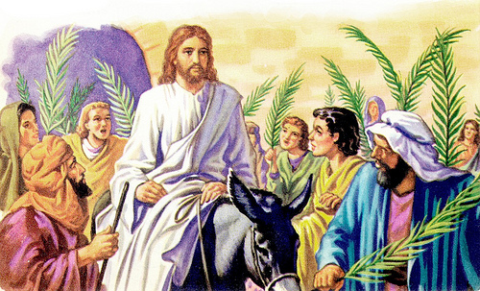
THE GUY WITH THE DONKEY by Max Lucado
When we all get home I know what I want to do. There's someone I want to get to know. I want to meet the guy with the donkey.
I don't know his name or what he looks like. I only know one thing: what he gave. He gave a donkey to Jesus on the Sunday he entered Jerusalem.
"Go to the town you can see there. When you enter it, you will quickly find a donkey tied there with its colt. Untie them and bring them to me. If anyone asks you why you are taking the donkeys, say that the Master needs them, and he will send them at once." (Matthew 21:3)
When we all get to heaven I want to visit this fellow. I have several questions for him.
Did you know? Did you have any idea that your generosity would be used for such a noble purpose? Did it ever occur to you that God was going to ride your donkey? Were you aware that all four gospel writers would tell your story? Did it ever cross your mind that a couple of millenniums later, a curious preacher in South Texas would be pondering your plight late at night?
Maybe you have those questions, too. All of us have a donkey. You and I each have something in our lives, which, if given back to God, could, like the donkey, move Jesus and His story further down the road. Maybe you can sing or program a computer or speak Swahili or write a check. Whichever, that’s your donkey. Whichever, your donkey belongs to God. Your gifts are His and the donkey was His.”

